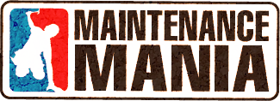
Present your products and/or services to fair maintenance professionals from across the state!
Every year for 3 days maintenance professionals from across the state gather to learn, share and obtain their certifications at an in-depth, hands on symposium designed and built just for them.
This is your opportunity to get in front of those potential customers in a small intimate venue who are actively looking for your products and services.
WHEN: Wednesday February 27, 2019 from 12:00-2:00
WHERE: Alameda County Fairgrounds
4501 Pleasanton Ave
Pleasanton, CA 94566
COST: $250.00
WHAT YOU GET: 8ft skirted table for Vendor Tradeshow
2-3 minute time to talk about your product/service during lunch

Sponsorship Agreement
Company Name: ___________________________Signature:______________________
Product/Category: __________________________________
Checks should be made payable to CFSA with Maintenance Mania on the comment line
Mail Checks to: California Fair Services Authority – Attn: Lesly Wade
1776 Tribute Road, Suite 100, Sacramento, CA 95815

For more information please contact Rich Sims at 925-596-5744 or via email at rsims@alamedacountyfair.com

